Contract Acceptance Testing (CAT)

Definition
# Source: Chatgpt (GPT‑5 Mini) at [8/22/2025]
Contract Acceptance Testing (CAT) is a type of acceptance testing performed to verify that the software product meets all the terms and conditions specified in a contractual agreement between the client and the vendor.
It ensures the deliverables adhere to the agreed scope, performance criteria, quality standards, and timelines before final acceptance and payment.

Objective
# Source: Chatgpt (GPT‑5 Mini) at [8/22/2025]
- Validate that all contractual obligations are fulfilled.
- Provide legal and financial assurance to both client and vendor.
- Ensure the product is delivered as per agreed specifications in the Statement of Work (SOW).

When is CAT Performed?
# Source: Chatgpt (GPT‑5 Mini) at [8/22/2025]
- At the final stage of project delivery, after system testing and UAT.
- Just before handover, final sign-off, and payment release.

Who Performs CAT?
# Source: Chatgpt (GPT‑5 Mini) at [8/22/2025]
- Client representatives (business stakeholders, project managers).
- Sometimes assisted by QA teams and legal teams for compliance verification.

What Does CAT Cover?
# Source: Chatgpt (GPT‑5 Mini) at [8/22/2025]
- All features and functionality promised in the contract are implemented.
- Performance benchmarks (response time, scalability) are achieved.
- Security standards (e.g., data encryption, access control) are met.
- Delivery deadlines and milestones are honored.
- Documentation (user manuals, technical guides) is complete.

Examples
# Source: Chatgpt (GPT‑5 Mini) at [8/22/2025]
- A government project where the vendor must deliver a payroll system with monthly salary processing under 2 seconds per transaction, as per contract.
- A banking app that must support 1 million concurrent users, as stated in the agreement.

Advantages
# Source: Chatgpt (GPT‑5 Mini) at [8/22/2025]
✔ Protects both parties legally and financially.
✔ Ensures vendor accountability for agreed deliverables.
✔ Avoids scope creep disputes.

Disadvantages
# Source: Chatgpt (GPT‑5 Mini) at [8/22/2025]
✘ Requires detailed documentation and contract clarity.
✘ Can lead to conflicts if contract terms are ambiguous.
✘ Time-consuming due to compliance checks.

✅ Difference Between CAT & UAT
# Source: Chatgpt (GPT‑5 Mini) at [8/22/2025]
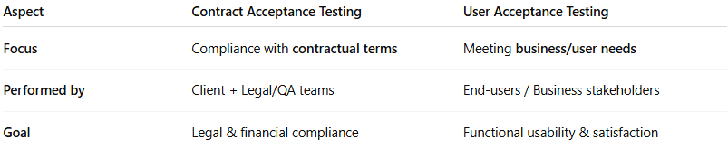
Aspect | Contract Acceptance Testing | User Acceptance Testing
Focus | Compliance with contractual terms | Meeting business/user needs
Performed by | Client + Legal/QA teams | End-users / Business stakeholders
Goal | Legal & financial compliance | Functional usability & satisfaction

